NEW BRIGHTON RUGBY FOOTBALL CLUB – A Brief history

Introduction
The New Brighton Rugby Football Club was established in 1894. At some stage between then and 1921, the club went into recess, but from 1921 onwards it has enjoyed continuous membership.
In earlier days locals felt that outsiders should have a permit to enter New Brighton from central Christchurch. Today the suburb of New Brighton still maintains its distinct boundaries - a clearly defined and identifiable area along the coastal margin of the city limits, accessed by crossing the Travis Swamp or the bridges across the Avon at South Brighton, New Brighton and Bower Avenue. Players and club members generally still have their roots in the area, with long-term family ties and links.

History of the jersey and club monogram and crest:
- 1953 – the senior team first played in the ‘full gold’ jersey; previously black with gold hoops.
- 1968 – The official club monogram and crest which remains today was first placed on club blazers and dress jerseys. Previously it had been a rugby player running in front of goal posts. Jim Geddes, a committee member, worked with William (Bill) Brittenden , first Principal of Aranui High School, and the school’s Art Teacher to develop the new design.
- 1994 – this monogram and crest was included on the playing strip for the first time (refer photos in clubrooms).

The story behind the Crest:
- The lion represents rampant strength – strong hearted. The blocks or keystones symbolise unity and strength.
- The lower segment is part of the city coat of arms – a sheaf of wheat with pukekos either side. Pukekos are swamp birds that live immediately behind the dunes. They are fiercely protective of their territory.
- ‘Kia Kaha’ means ‘Be strong’ – this is a ‘do now’ action phrase.

Club Colours:
- Black- represents unlimited potential – never allow this to be squashed. Use and develop your talents and skills.
- Gold of the wheat and/or the pingau found in the dunes. Pingau is a form of marram grass – a hardy plant whose deep roots spread out widely, holding the dunes together.

Combined, these stories demonstrate the 3 things the New Brighton Rugby Football Club stands for and believes in.
- Fiercely protective of local area and its people (separated from centre of Christchurch by Travis Swamp).
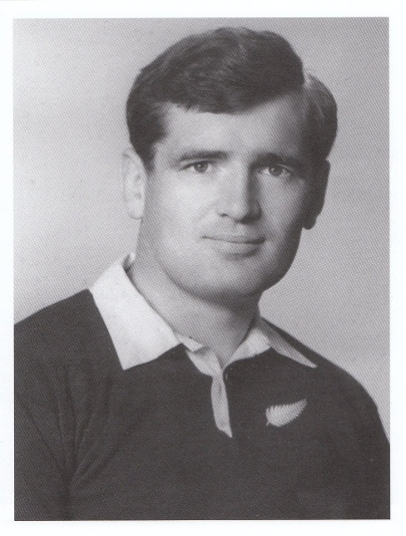
- Unity – family
- Strength of character

Championship Titles

The New Brighton Senior Team has won the senior
club championship FOUR times:

- 1968; 1971(shared the title)
- 1978; 1984*

New Brighton’s two All Blacks:
1. Dr Hugh C. Burry (1960) - now Patron of the Club.
2. Kerry J. Tanner (1974-76)
Dr Hugh. C. Burry, Club Patron

The Present

At the present time, the start of the 2009 season, the club has healthy player numbers with 6 open teams and 20 junior teams. The steady advance in the senior division one team’s standings over the past 5 years has been a testament to the hard work of many. Since 2005 the club has had 10 players take up professional contracts (7 in other parts of the country and abroad) which is testament to the level the club is currently working at. We have three current NPC players and Crusaders in Ryan Crotty, Tyson and Isaac Ross who all contribute to the Club and on and off the field when free from contractual duty.

Financially the Club lies in reasonable stead with the balance sheet placing assets in excess of $1.7m. However, ten years on from the inception of professional rugby, the subtle but increasing financial pressures that have come along are beginning to mount. Alike other Clubs, escalating maintenance and day-to-day running costs has demanded a shift from the traditional Rugby Club to a more business structured model. The recent elevation in beach front property values has given rise to the relocation idea currently referred to as the ‘Rawhiti Domain Project’. Club Chairman Wayne Turner is exploring a range of options relating to a shift from the existing Club house to a new facility closer to the number one playing ground and all is looking good for a move in the near future.

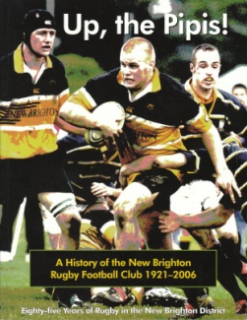
Up the Pipis!

For a full and comprehensive history of the New Brighton Rugby Football Club 1921-2006 buy a copy of Dick Hockley’s ‘Up the Pipis!’ Eighty-five Years of Rugby in the New Brighton District. Dick passed away recently but his contribution to the Club, and especially his work in compiling the official history of New Brighton Rugby, will always be remembered. Order forms for the book are available under the history tab, otherwise contact or visit the club to attain a copy.

